**1. (20%) The followings are Java code that have the SQL injection vulnerability, where id is an input.**

**In Java, "abc" (in a pair of double quotes) is a string. "abc" + x is to concatenate the string "abc" and the variable x.**

**(a) If id is an integer, the query string will be the following. Show two exploitations that always makes a true condition of the query.**

**Id = 1**

**String query = "select name from students where id = 1;**

**Id = 2/1**

**String query = "select name from students where id = 2/1;**

**(b) If id is a string, the query string will be the following. Show two exploitations that always makes a true condition of the query.**

**String query = "select name from students where id = '" + id + "';";**

**Id = “ x or x == x;”**

**String query = "select name from students where id = x or x =x;”**

**Id = “TRUE;”**

**String query = "select name from students where id = TRUE;”**

**2. (20%) In a Linux (or Linux subsystem), create a text file, name it as foo.txt. Then make sure you can run "cat foo.txt".**

**(a) Trace the libraray calls of "cat foo.txt". Use the command "ltrace cat foo.txt". Copy and paste the result in your report.**

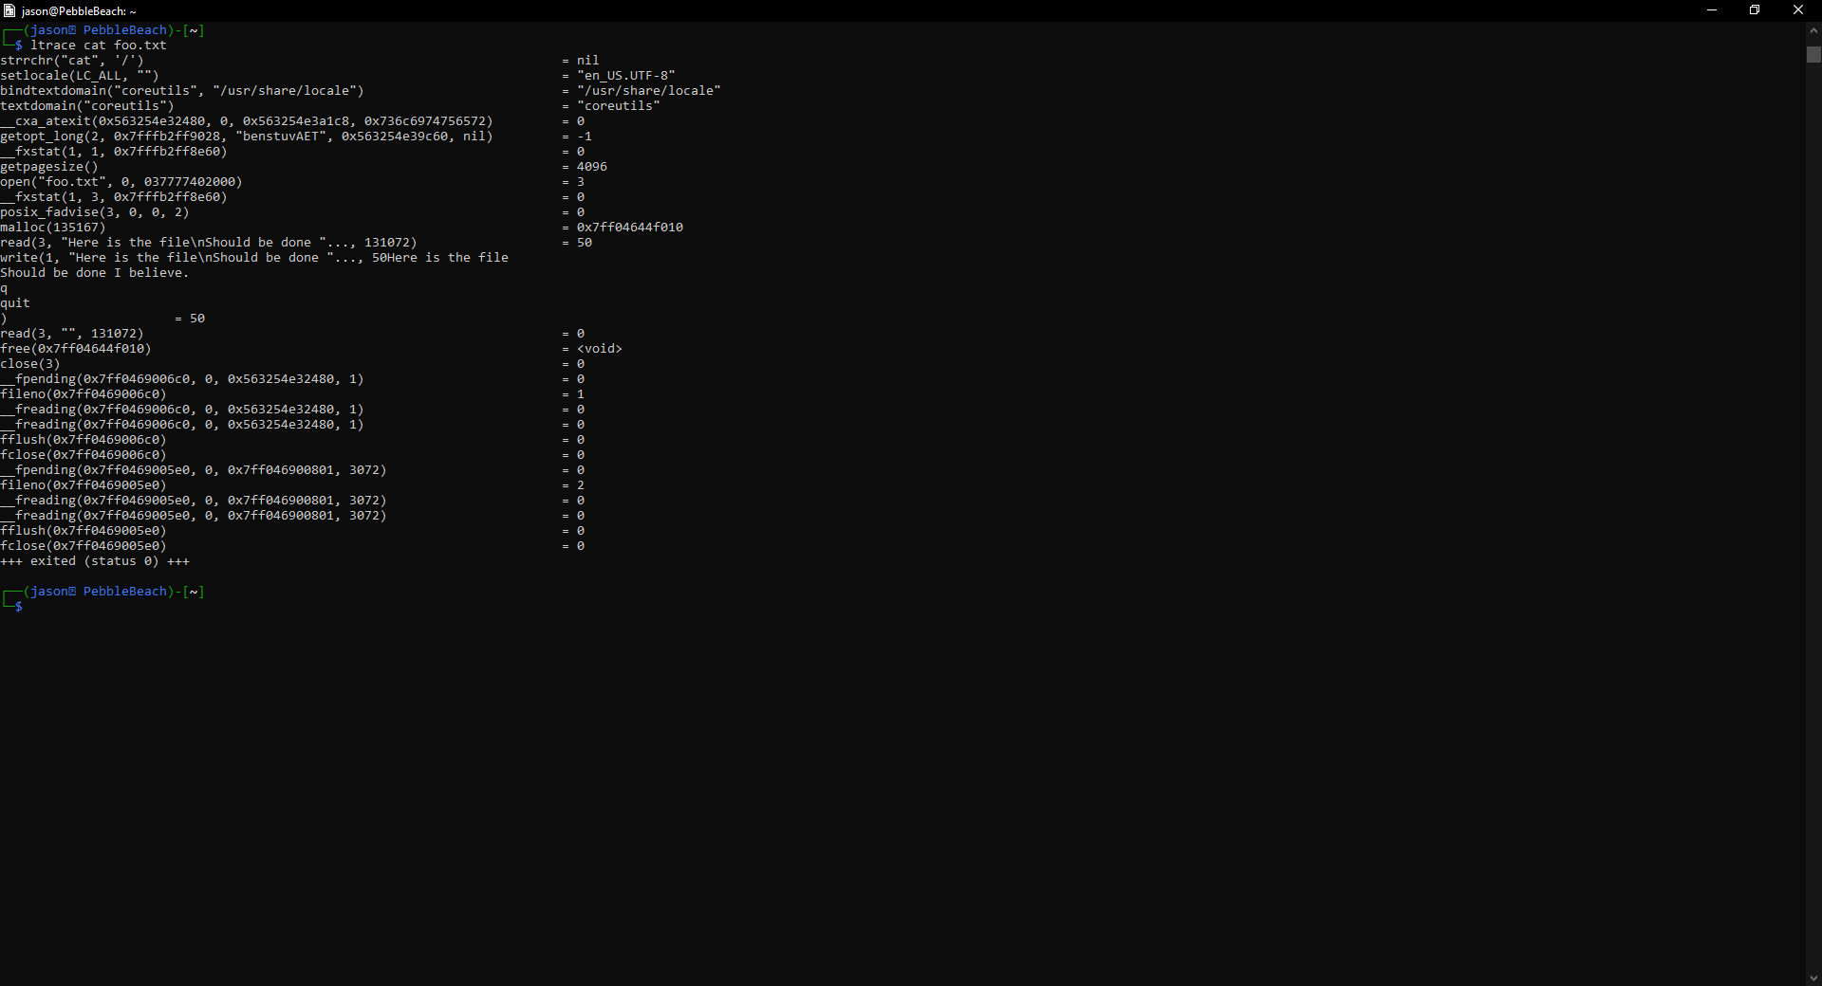

**(b) Explain what is the first library call in your result.**

**The first is strchr function is called from the string library. This call is finding the function to read the character string cat.**

**(c) Trace the system calls of "cat foo.txt". Use the command "strace cat foo.txt". Copy and paste the result in your report.**

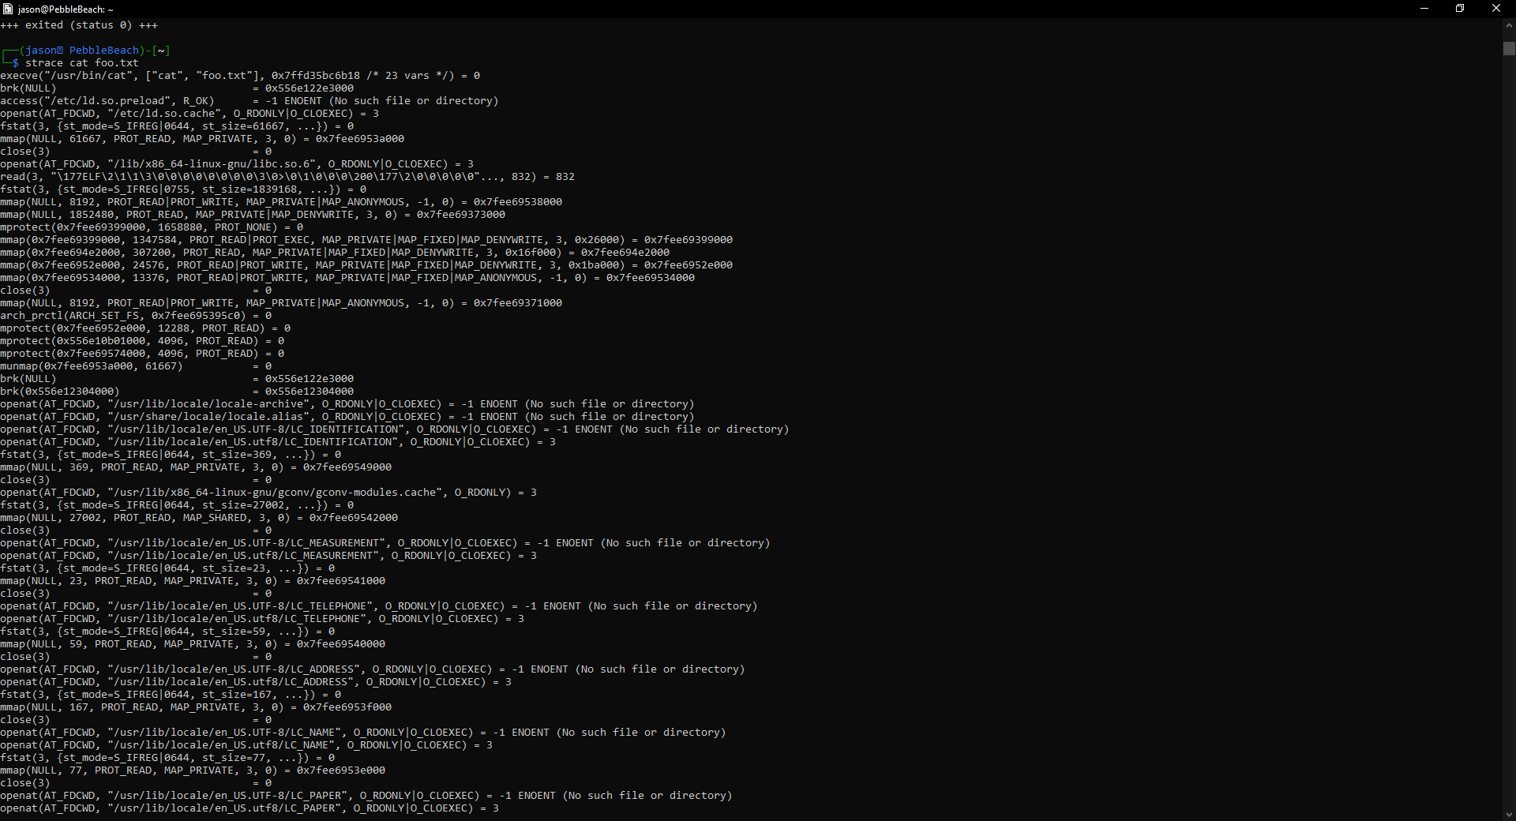

**(d) Explain what is the first system call in your result.**

**execve("/usr/bin/cat", ["cat", "foo.txt"], 0x7ffd35bc6b18 /* 23 vars */) = 0**

**execve() executes the program pointed to by *“/usr/bin/cat”*. *This runs the cat call on foo.txt as shown in the array argument.***

**3. (10%) Convert the following script to a normal html without the javascript script. Copy and paste the converted html in your submission.**

**<pre style='text-align: left; border: 1px dashed #008DEF; line-height: 18px; padding: 15px; font-size: 13px; font-family:'Courier New', Courier, monospace; overflow: auto;'>document.write(unescape(<span style='color:#2A00FF'>'%3C%68%74%6D%6C%3E%0A%3C%74%69%74%6C%65%3E%45%6E%63%72%79%70%74%65%64%20%48%54%4D%4C%3C%2F%74%69%74%6C%65%3E%0A%3C%62%6F%64%79%3E%48%65%6C%6C%6F%20%77%6F%72%6C%64%21%3C%2F%62%6F%64%79%3E%0A%3C%2F%68%74%6D%6C%3E'</span>));</pre>**

**….**

**The hex code comes back as seen below showing this is a hello world program:**

**<html>**

**<title>Encrypted HTML</title>**

**<body>Hello world!</body>**

**</html>**

**4. (10%) DoS attacks could target computing capacity by exhausting processes and CPU time. In Linux, we can use the command "ulimit" to stop this kind of DoS attacks. Show and discuss the two options of "ulimit" that are needed to stop the attack by limiting processes and CPU time?**

**Ulimit -u limits processes users can be run by an individual user.**

**Ulimit -t limits number of processes by a user so that the limit cannot exceeded the max number of CPU time.**

**5. (10%) File checksum is often used to check if a file was maliciously modified.**

**(a) In Linux, what is the command to get a sha256 checksum of a file?**

**Sha256sum example.txt**

**(b) What is the sha256 checksum of "hw4.txt"?**

**56f7655e968bcb574f4c34a4146fe1fbabbc7179**

**(c) Add a space to any place in "hw4.txt", and recompute and show the new sha256 checksum of "hw4.txt"**

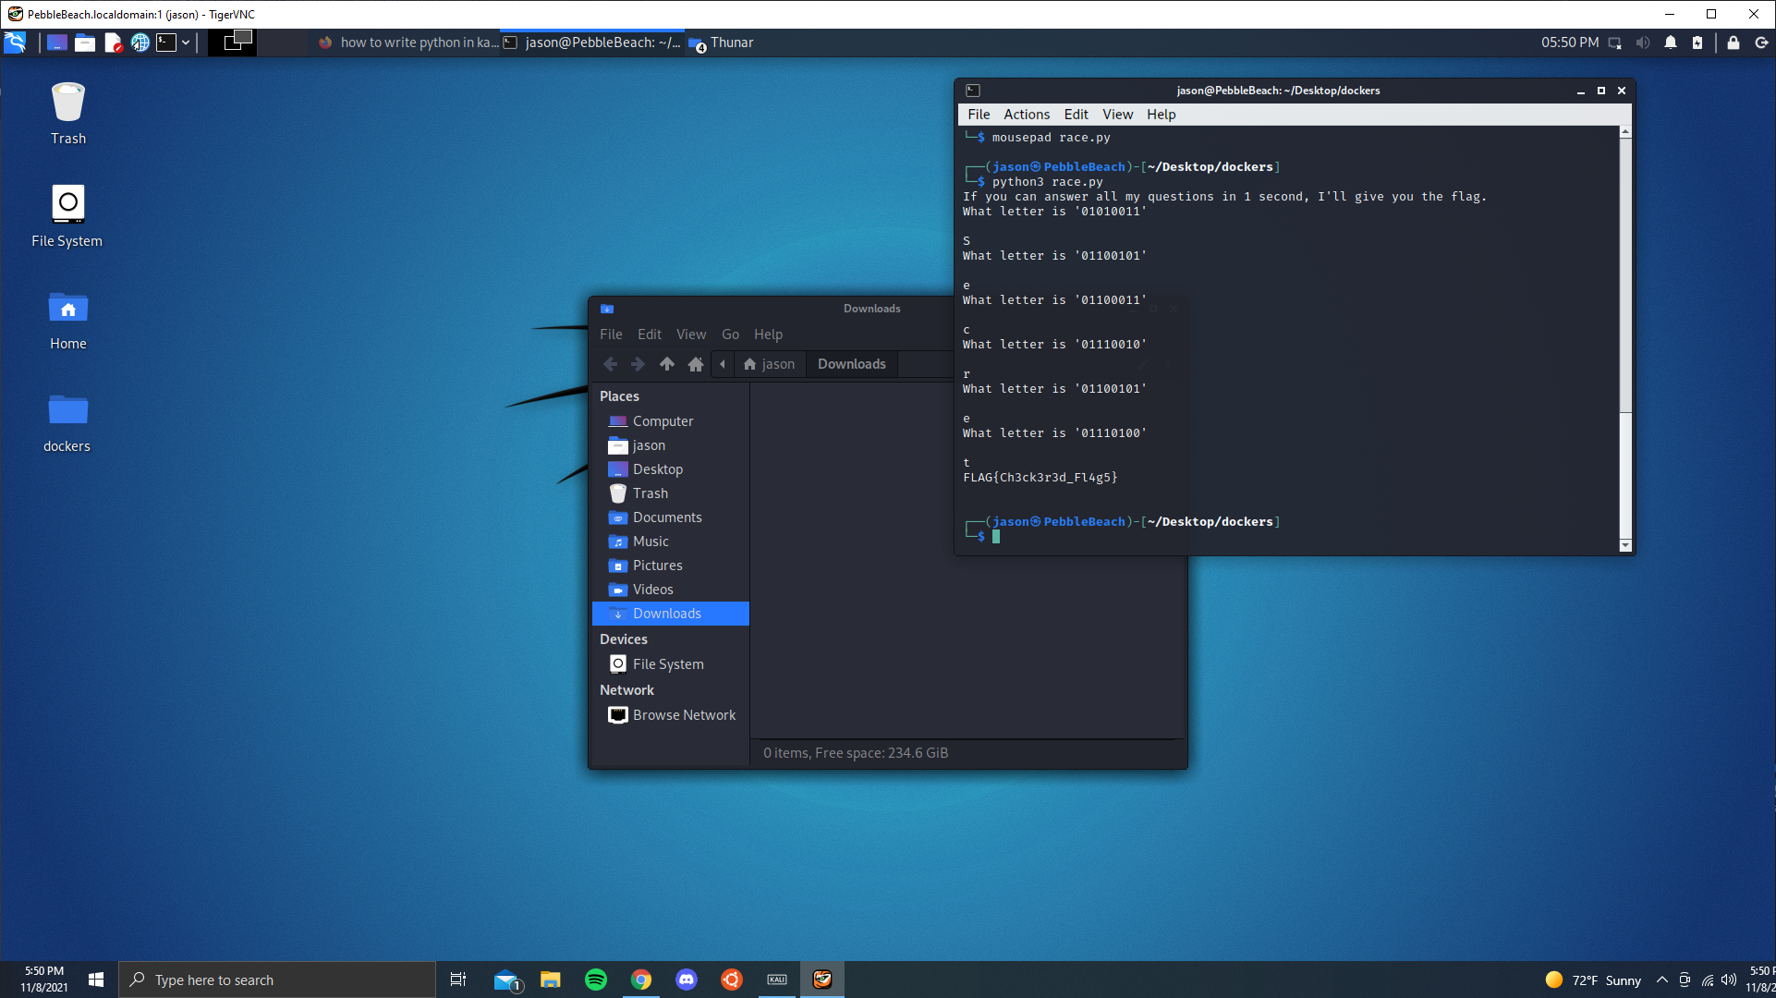**0e2c730a53fa35c062d02c3bf423bb217d232654**

**DOCKER IMAGE 1.race**

**Docker Image 2.catch**

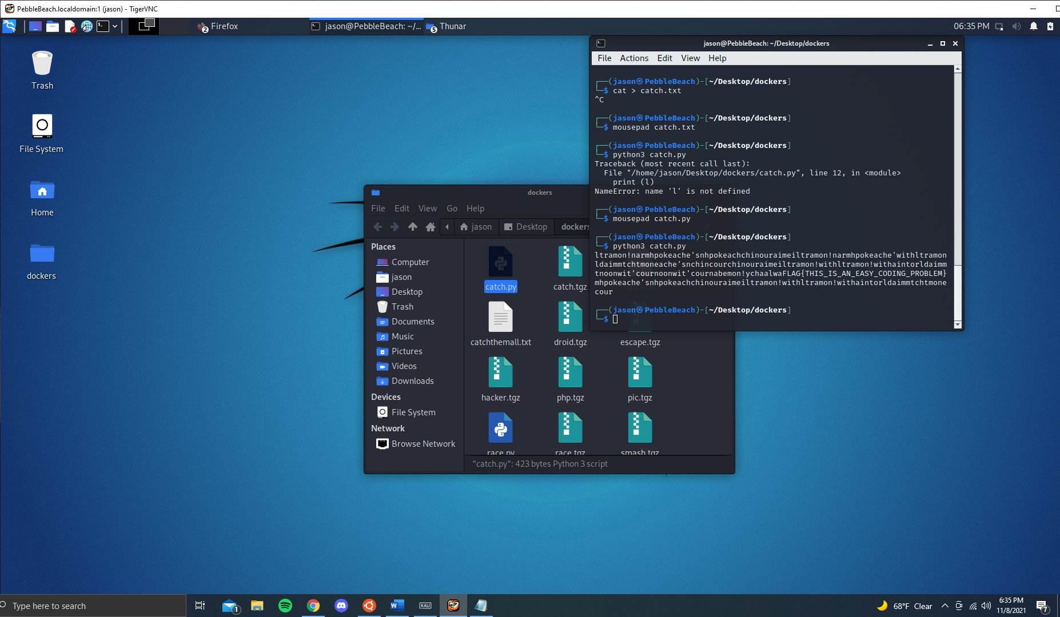

**Docker 4.escape**

